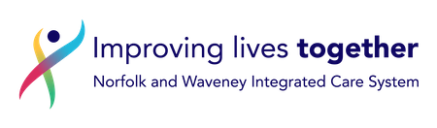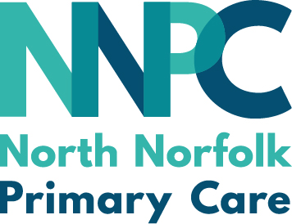

Expression of Interest: Pharmacy Cancer Referral Service

Community Pharmacy Norfolk is pleased to announce that we have been commissioned to support and programme manage the roll out of a Pilot Cancer Referral Service through selected Community Pharmacies in Norfolk and Waveney. This project is supported by the NHS England Pharmacy Integration Team, the East of England North Cancer Alliance, Norfolk and Waveney Integrated Care Board, and the North Norfolk Primary Care Rapid Diagnostic Service.

We are now seeking expressions of interest (EOI), from any pharmacy in Norfolk & Waveney, who would like to be involved with this pilot service. Please see a link to the EOI form below.

Norfolk and Waveney ICB will be making the final selection of pharmacies to pilot the service based on the information you provide in the EOI and against pre-determined selection criteria. The selected pharmacies will then be informed, fully supported to train, prepare and offer the service. We anticipate pilot rollout will occur in two phases, with around 20 pharmacies in total involved. The “first wave” of participating pharmacies will commence service provision during January 2024

Though part of a national pilot, the clinical model in Norfolk and Waveney will be somewhat different to that deployed in other pilot areas in that patients will be taken through a clinical protocol within the pharmacy and then, if appropriate, referred mainly onto the Rapid Diagnostic Service RDS. Patients will then be contacted and assessed by the RDS and referred onwards for further investigations and treatment where necessary.

Pilot pharmacies will receive a setup fee of£390 to recognise the costs involved in training and preparation. Additional monthly payments will be made based on the number of consultations conducted and submission of a complete and accurate dataset. Details can be found here.

If you would like to provide this service from your pharmacy please complete the expression of interest form- CLICK HERE by 29th November 2023.

If you have issues with the above link, please paste the following into your browser:
https://forms.office.com/Pages/ResponsePage.aspx?id=XMXbQhAIxUOeck7FtqLsvhxC04WdGnhGuROTJccbiFxUQVo4WVc5RTMyQkZVUVJKNzBTSjBUTEs5WS4u

If you are part of a multiple organisation, please seek approval to complete this form before doing so from your Area Manager or Head Office.

If you have any queries regarding the above, please contact Charlotte Bowles, Support Officer for Community Pharmacy Norfolk Charlottebowles@norfolkpharmacies.co.uk
Thank you.

